NPC – UNIT 4 ASSIGNMENT
REPORT
Topic: Configure DHCP and Set Up a Network Using Cisco Packet Tracer

Submitted by: Siddhi Rajesh Lute
PRN Number: 2125UCSF1098
Semester: 3
Subject: NPC
Department: Cyber Security
College: Sanjivani University
Academic Year: 2026-27

- Aim :
To create a network topology using Cisco Packet Tracer, configure a DHCP server, assign IP addresses automatically to PCs, and verify connectivity between the computers using the ping command.

2. Software and Components Required :
- Cisco Packet Tracer
- Two PCs (PC0 and PC1)
- One Cisco 2960 switch (Switch0)
- One server (Server0)
- Copper straight-through cables

3. Network Topology :
A simple Local Area Network (LAN) was created in Cisco Packet Tracer. PC0, PC1, and Server0 were connected to the Cisco 2960 switch using copper straight-through cables.
The switch allows the connected devices to communicate within the network, while the server provides DHCP services to assign IP configuration to the PCs.
Connections :
- PC0 FastEthernet0 → Switch0 FastEthernet0/1
- PC1 FastEthernet0 → Switch0 FastEthernet0/2
- Server0 FastEthernet0 → Switch0 FastEthernet0/3

Network Topology
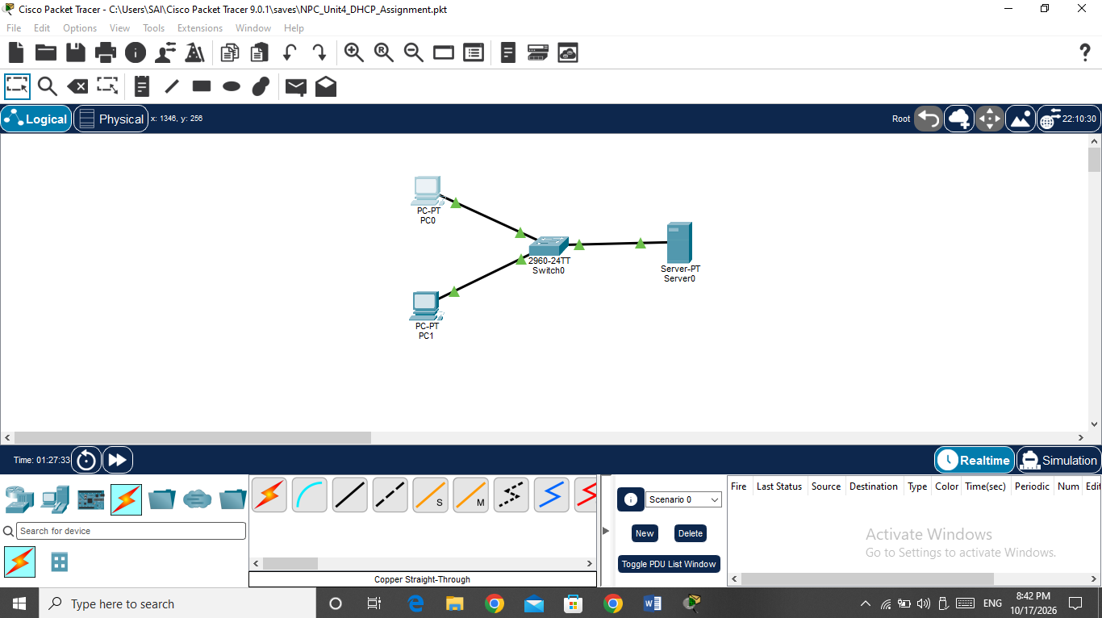

4. Static IP Configuration of the DHCP Server :
The server was assigned a static IP address so that it could provide DHCP services to the network using a consistent address.
Steps:
- Open Server0 in Cisco Packet Tracer.
- Select the Desktop tab.
- Open IP Configuration.
- Select the Static option.
- Enter the following network settings.

Parameter | Configuration
IP Address | 192.168.1.2
Subnet Mask | 255.255.255.0
Default Gateway | 192.168.1.1
DNS Server | 192.168.1.2
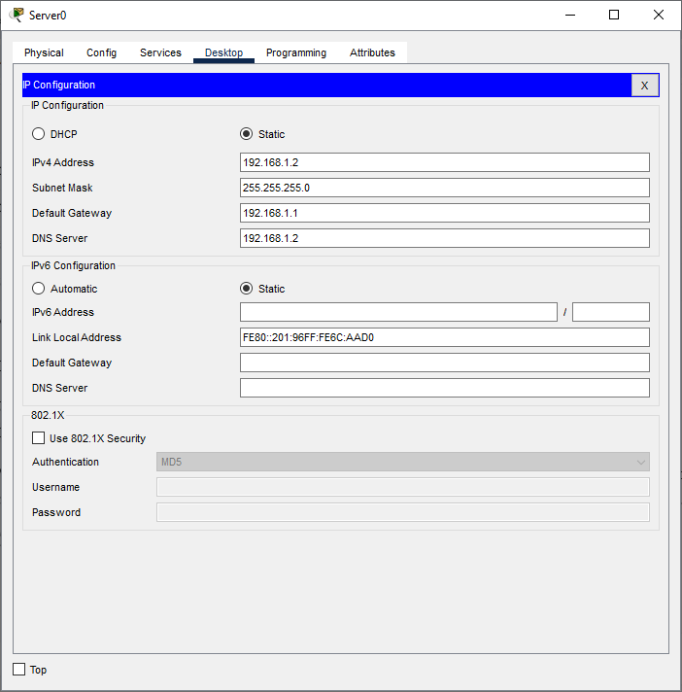

Server Static IP Configuration

5. DHCP Service Configuration :
Dynamic Host Configuration Protocol (DHCP) automatically assigns IP addresses and other network settings to client devices. This reduces the need to configure each PC manually.
Steps:
- Open Server0.
- Select the Services tab.
- Click DHCP.
- Turn the DHCP service On.
- Create a DHCP pool named LAN_POOL.
- Enter the following configuration and save it.
Parameter | Configuration
Pool Name | LAN_POOL
Default Gateway | 192.168.1.1
DNS Server | 192.168.1.2
Start IP Address | 192.168.1.10
Subnet Mask | 255.255.255.0
Maximum Users | 20
The DHCP service was enabled to provide automatic IP configuration to the client PCs.

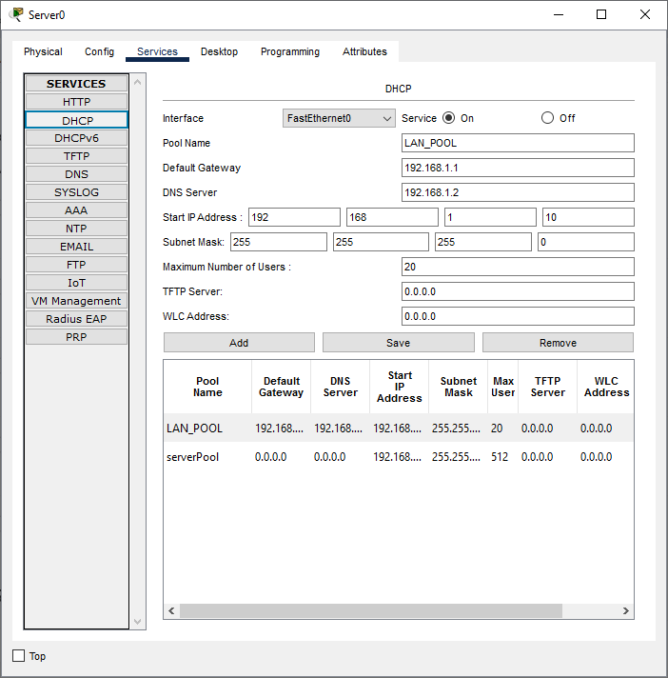

Service and Pool Configuration

6. Automatic IP Configuration of PCs :
Both PCs were configured to obtain their IP addresses automatically through DHCP.
Steps:
- Open PC0.
- Select the Desktop tab.
- Click IP Configuration.
- Select DHCP.
- Observe the assigned IP configuration.
- Repeat the same steps for PC1.
The PCs obtained IP configurations automatically, including IP addresses and subnet masks.

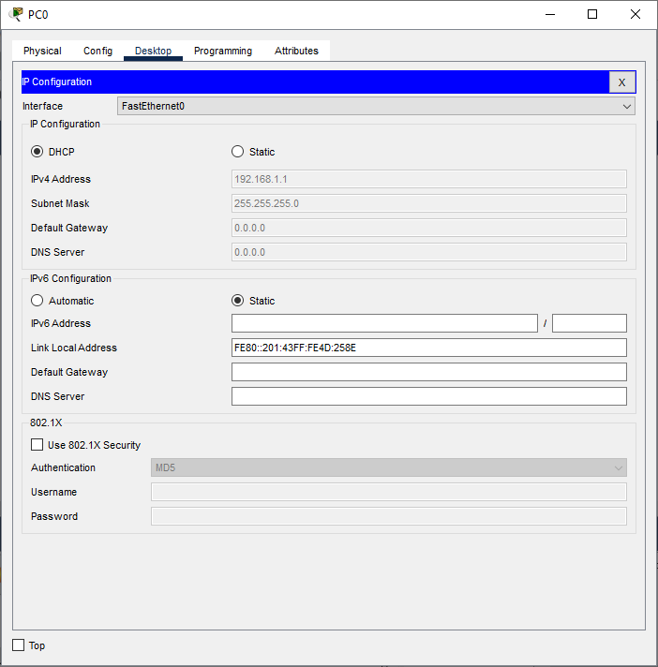

- PC0 IP Configuration
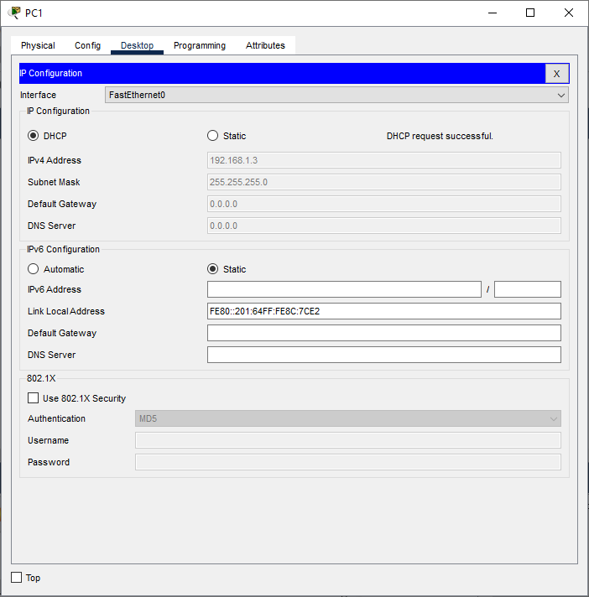

- PC1 IP Configuration

7. Connectivity Testing Using Ping :
The ping command was used to verify communication between PC0 and PC1. It sends test packets to another device and displays whether replies are received.
Steps:
- Open PC0.
- Select the Desktop tab.
- Open Command Prompt.
- Enter the command:
ping 192.168.1.3
- Press Enter and observe the output.
The command returned successful replies from PC1, demonstrating that communication between the two PCs was established.
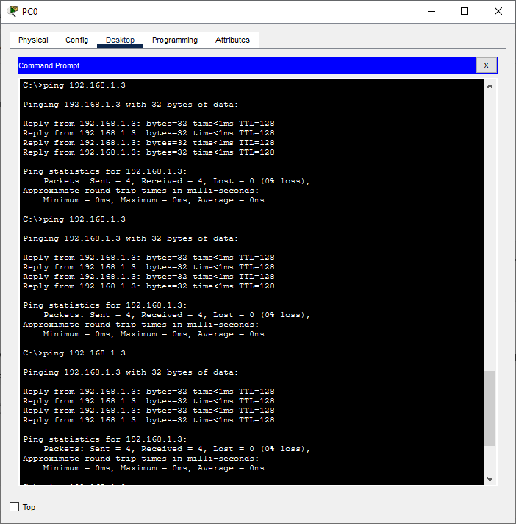

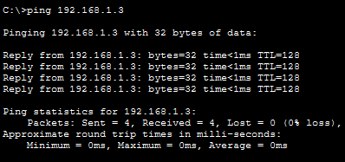
Successful ping test

8. Result :
The network topology was created successfully in Cisco Packet Tracer. The server's static IP configuration and DHCP service were configured, and both PCs were set to obtain their IP configurations automatically. Connectivity between PC0 and PC1 was tested successfully using the ping command.

9. Conclusion
This practical demonstrated the creation of a LAN using Cisco Packet Tracer, static IP configuration, DHCP service setup, automatic IP assignment, and connectivity testing. It provided practical knowledge of basic network configuration and communication between devices connected through a switch.

